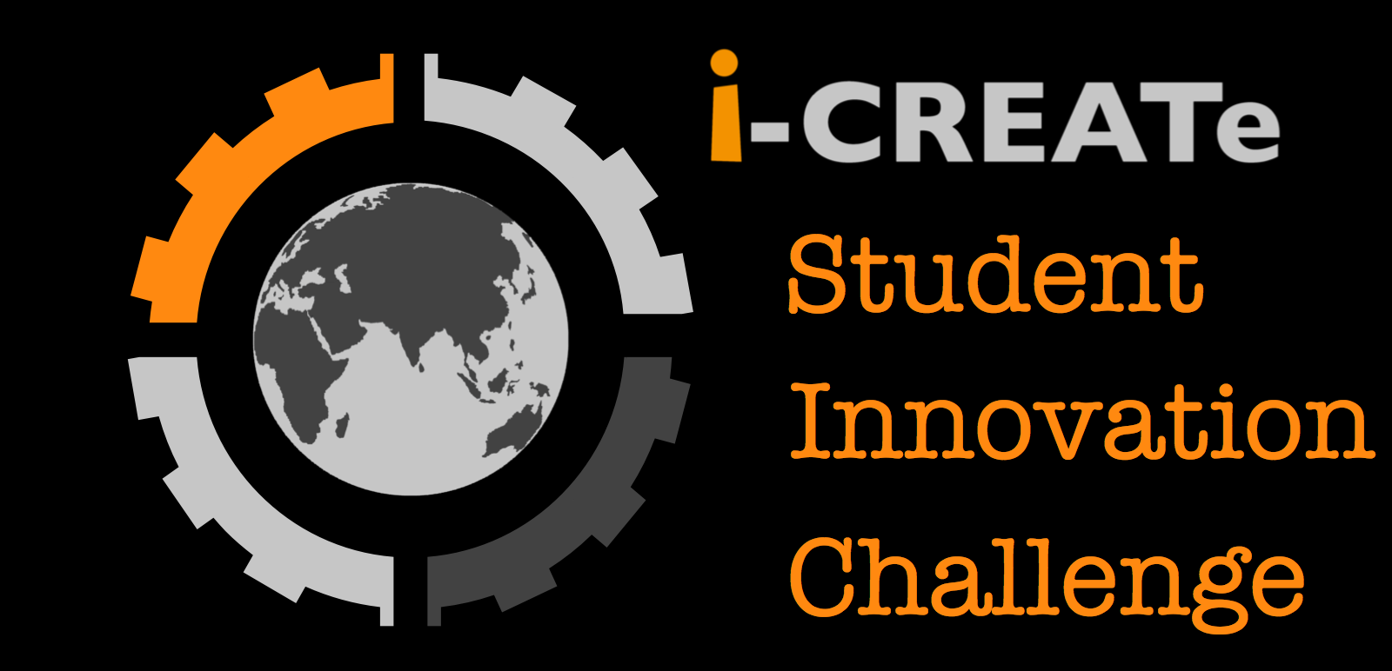

GLOBAL STUDENT INNOVATION CHALLENGE 2023
ENTRY FORM

ORGANIZED BY:

Entry Number:

(Official use only)

1. Title of the Project / Device

2. Particulars of Applicant

Name:
(Advisor/ Supervisor’s in-charge)

Contact Phone No:
Email:

School/Institution:
Department/Faculty:
Address (for billing):

2.1. Particulars of other team members
*Please enter name(s) in full [no nicknames as name(s) will be use for certificate and documentation].

Name:
(Team member #1/ Team leader)
Contact No:

Name:
(Team member #2)
Email:

Name:
(Team member #3)
Email:

Name:
(Team member #4)
Email:

Name:
(Team member #5)
Email:

3. Categories

Please tick on one of the following

☐ Design Category | ☐ Technology Category

4. Project Description

Give a brief description of your project: Objectives of the project. Who are the target users? Why does the user need this? Have the users been consulted? Feature design or technologies used, safety precaution, etc. You may also include some pictures or illustration of your project. (*Please try not to exceed 1000 words)

5. Additional Information about the Project/Device

Has your Project/Device been submitted to any other competition or won any award? If yes, please provide details.

Other points or aspects that you would like to highlight, if any.

Has your Project/Device been patent? If yes, please provide details.

6. Abstract

Please write a short summary of the overall Project/Device and should not exceed 200 words.

